AI-BASED DIGITAL EMPLOYEE USING AN AGENT

A Report for the subject of Software Engineering Lab

Bachelor of Technology in
Computer Science and Engineering

Submitted by:
Name: Samuel Priyatam Dash
Registration no.: 2302040025
Semester: 6th
Subject name: Software Engineering (SE) Lab

Under the esteemed guidance of
Prof. Himansu Sekhar Behera
Professor and Head


DEPARTMENT OF COMPUTER SCIENCE AND ENGINEERING

VEER SURENDRA SAI UNIVERSITY OF TECHNOLOGY, BURLA

DEPARTMENT OF COMPUTER SCIENCE AND ENGINEERING
VEER SURENDRA SAI UNIVERSITY OF TECHNOLOGY, BURLA


CERTIFICATE

This is to certify that the project entitled "AI-based Digital Employee using an Agent" is being submitted by Mr. Samuel Priyatam Dash (Regd. No. 2302040025) from the Department of Computer Science and Engineering, Veer Surendra Sai University of Technology, Burla. This report is an original work carried out by him under our supervision and guidance.

Date: 13/04/2026

Prof. Himansu Sekhar Behera
Head of Department, Supervisor
Computer Science and Engineering
VSSUT, Burla

DEPARTMENT OF COMPUTER SCIENCE AND ENGINEERING

VEER SURENDRA SAI UNIVERSITY OF TECHNOLOGY, BURLA


CERTIFICATE FOR APPROVAL
This is to certify that the project report entitled "AI-based Digital Employee using an Agent" is being submitted by Mr. Samuel Priyatam Dash (Regd. No. 2302040025), a student of the Department of Computer Science and Engineering, Veer Surendra Sai University of Technology, Burla, has been thoroughly examined and evaluated by us. This report is an original work carried out by the candidate under our supervision and guidance, and it meets the requirements for submission as per the academic guidelines of the university.

Ms. Swarupa Panda Prof. Himansu Sekhar Behera
Examiner, Guest Faculty Head of Department, Supervisor
Computer Science and Engineering Computer Science and Engineering
VSSUT, Burla VSSUT, Burla

DEPARTMENT OF COMPUTER SCIENCE AND ENGINEERING

VEER SURENDRA SAI UNIVERSITY OF TECHNOLOGY, BURLA


Declaration

I hereby declare that the project work entitled "AI-based Digital Employee using an Agent" is the result of my original research and effort, carried out under the esteemed supervision of Prof. Himansu Sekhar Behera, Department of Computer Science and Engineering, Veer Surendra Sai University of Technology, Burla. I confirm that this project is an authentic piece of work and has not been submitted, either in part or in full, for the award of any degree, diploma, or certification at any other institution or university. All sources of information used in this report have been duly acknowledged.

` Samuel Priyatam Dash
Regd No. - 2302040025

Acknowledgement

I express my sincere gratitude to my supervisor, Prof. Himansu Sekhar Behera, for providing me with the opportunity to undertake this project. I am deeply appreciative of his insightful guidance, timely advice, continuous support, and motivation throughout my research. His kindness and invaluable contributions have been instrumental in the successful completion of this work.

I extend my heartfelt thanks to all the faculty and staff members of the Department of Computer Science and Engineering, Veer Surendra Sai University of Technology, Burla, India, for their constant support and assistance. I am especially grateful to Prof. Dipak Kumar Sahoo, Vice Chancellor, VSSUT, Burla, and Prof. Himansu Sekhar Behera, Head of the Department, Department of Computer Science and Engineering, for their encouragement and for providing me with the necessary resources and facilities throughout my academic journey.

Finally, I would like to express my deepest gratitude to my family for their unwavering love, encouragement, and support, which have been my greatest source of strength.

` Samuel Priyatam Dash
Regd No. - 2302040025

Abstract
The rapid advancement of artificial intelligence and automation technologies has transformed the way organizations manage operations and decision-making processes. In modern enterprises, a significant amount of managerial effort is spent on repetitive, rule-based, and multi-step tasks that require coordination across different systems and platforms. This project proposes the design and conceptual development of an AI-Based Digital Employee using an Agentic Architecture, aimed at automating such tasks efficiently.
The system introduces a digital employee in the form of an intelligent software agent that can receive high-level instructions from managers and autonomously execute them. The agent interprets instructions, decomposes them into structured tasks, and performs actions by interacting with external tools and services through APIs and integrations. The system ensures seamless execution by incorporating task management, decision-making, and logging mechanisms.
To systematically model the system, various Software Engineering methodologies have been applied. The Entity Relationship (ER) model defines the core data structure, including entities such as users, requests, tasks, decisions, and system logs. The Data Flow Diagrams (DFD) illustrate how data moves through different levels of the system, from user input to execution and output generation. Additionally, Use Case Diagrams and Structure Charts provide a clear understanding of system functionality and modular design.
The proposed system emphasizes scalability, modularity, and automation. By reducing manual intervention, improving efficiency, and enabling intelligent decision support, the AI-based digital employee can significantly enhance productivity in organizational workflows. This project lays a strong foundation for future development of fully autonomous enterprise agents capable of handling complex business processes.

TABLE OF CONTENTS

1. Problem Statement & List of Actors 8
1.1 Objective. 8
1.2 Problem Description. 8
1.3 List of Actors 9
1.4 Conclusion 9
2. Software Requirement Specification (SRS) 10
2.1. Introduction 10
2.2. Overall Description 11
2.3 External Interface Requirements 12
2.4. Functional Requirements Analysis 13
2.5. Non-Functional Requirements 15
2.6 Goals of Implementation 15
2.7 Design Constraints 15
2.7 Conclusion 16
3. ER Model (Entity Relationship Model) 17
3.1 Objective 17
3.2 Entities and Attributes 19
3.3 Entity Relationship Mapping 19
3.4 Key Constraints 20
3.5 Entity Relationship Diagram 21
3.6 Conclusion 21
4. DATA FLOW DIAGRAM (DFD) 22
4.1 DFD Level 0 (Context Diagram) 23
4.2. DFD Level 1 26
4.3. DFD Level 2 (Detailed Breakdown) 27
4.4. Data Stores Description 28
4.5 - Data Flow Process table 29
4.6. Data Flow Diagram 30
4.7 State Chart Diagram 31
5. UML Diagrams 23
5.1 Use Case Diagram And User Flow 27
5.2 Class Diagram 28
5.3 Object Diagram 29
5.4 Activity Diagram 30
5.5 State Chart Diagram 31
5.6 Sequence Diagram 32
5.7 Collaboration Diagram 33
6. Conclusion 34

1. Problem Statement & List of Actors

1.1 Objective
To prepare the problem statement for any project and find the list of end users using the system.

1.2 Problem Description
In many organizations, managers and team leads regularly assign routine tasks such as data collection, report generation, information retrieval, updating records, and coordinating actions across multiple software tools. These tasks are often repetitive, time-consuming, and require continuous human involvement, even though they do not demand complex decision-making.
With the increasing use of digital tools and online services, human employees are required to manually switch between different applications to complete assigned work. This leads to inefficiency, delays, and increased operational overhead. Managers also need to closely monitor task execution and follow up frequently, which further increases workload.
To address this issue, there is a need for a digital employee that can receive instructions directly from a manager and execute assigned tasks automatically. Such a digital employee should be capable of understanding task instructions, selecting appropriate actions, interacting with existing software tools, and reporting task status back to the manager.
The proposed system focuses on designing an AI-based digital employee using an agent approach, where the digital employee acts as an independent worker that assists human employees rather than replacing them. The digital employee performs routine tasks autonomously while allowing human supervision and intervention when required.
The objective of this project is to reduce manual effort, improve efficiency, and support managers by delegating repetitive operational tasks to a digital employee that operates based on given instructions.

1.3 List of Actors

Manager / Supervisor

Provides task instructions to the digital employee.

Reviews task execution results and progress reports.

Intervenes when tasks require human decision-making.

Human Employee
- Collaborates with the digital employee.
- Handles tasks escalated by the digital employee.
- Uses outputs generated by the digital employee.

Digital Employee (AI Agent)

Receives instructions from the manager.

Interprets tasks and determines required actions.

Executes tasks using available tools.

Reports task completion status or errors.

System Administrator
- Configures the digital employee.
- Manages access permissions and system settings.
- Monitors system performance and logs.

External Tools / Services

Software applications or platforms used by the digital employee to complete tasks.

May include data sources, communication tools, or task execution utilities.

1.4 Conclusion
The problem statement for the AI-Based Digital Employee Using an Agent Approach was successfully formulated from an organizational perspective without describing implementation details. Based on the problem description, the key actors interacting with the system were identified and documented. This problem statement and actor list will serve as the foundation for requirement analysis, system modeling, and preparation of the Software Requirement Specification (SRS) document.
2. SOFTWARE REQUIREMENT SPECIFICATION (SRS) DOCUMENT FOR AI-BASED DIGITAL EMPLOYEE USING AN AGENT
2.1. Introduction

2.1.1 Purpose
This Software Requirements Specification (SRS) document describes the requirements for the AI-Based Digital Employee Using an Agent Approach. The purpose of this document is to provide a clear and complete description of the system’s functional and non-functional requirements. This document serves as a reference for system design, implementation, and testing.

2.1.2 Document Conventions
This document follows the IEEE Software Requirements Specification standard.
The word “shall” is used to indicate mandatory requirements.
Functional requirements are uniquely identified using requirement IDs (REQ-x).

2.1.3 Intended Audience and Reading Suggestions
This document is intended for:
- Software developers
- Project supervisors
- Test engineers
- System analysts
- Academic evaluators
Readers are advised to begin with the Introduction and Overall Description sections to understand system context, followed by System Features for detailed requirements.

2.1.4 Product Scope
The product is an AI-based digital employee that receives task instructions from a manager and executes them using an agent-based approach. The system aims to reduce manual effort by automating routine operational tasks while allowing human supervision. The digital employee assists human workers rather than replacing them.

2.1.5 References
- IEEE Std 830-1998 - IEEE Recommended Practice for Software Requirements Specifications
- Software Engineering Laboratory Manual
- Sommerville, Ian - Software Engineering

2.2. Overall Description

2.2.1 Product Perspective
The AI-Based Digital Employee is a standalone software component designed to assist organizations in automating routine tasks. It is not a replacement for existing systems but interacts with them to execute assigned actions. The digital employee operates under managerial control and performs tasks based on received instructions.
2.2.2 Product Functions
At a high level, the system performs the following functions:
- Accepts task instructions from a manager
- Interprets and analyzes instructions
- Decomposes tasks into subtasks
- Executes tasks using available tools
- Monitors execution progress
- Reports results to the manager
- Logs all activities
2.2.3 User Classes and Characteristics

i. Manager
- Assigns tasks to the digital employee
- Reviews execution results
- Requires minimal technical expertise

ii. Human Employee
- Collaborates with the digital employee
- Handles escalated tasks

iii. System Administrator
- Configures the system
- Manages access permissions
- Monitors logs

2.2.4 Operating Environment
- Operating System: Windows / Linux
- Interface: Command-line or web-based interface
- Execution Environment: Standard workstation or server
- Network: Internet or local network

2.2.5 Design and Implementation Constraints
- The system must operate within organizational policies
- Only predefined tools may be accessed
- The system must not perform unauthorized actions
- Human supervision must always be possible

2.2.6 User Documentation
- User manual for managers
- Administrator setup guide
- System usage instructions
2.2.7 Assumptions and Dependencies
- Managers provide clear task instructions
- External tools are available and accessible
- Network connectivity is stable
- Tasks are limited to predefined operational scope
2.3. External Interface Requirements

2.3.1 User Interfaces
- Instruction input interface for managers
- Task status and result display
- Error and escalation notifications

2.3.2 Hardware Interfaces
- No specific hardware interfaces required
- Runs on standard computing devices

2.3.3 Software Interfaces
- Interfaces with external software tools
- Access to data sources and services
- Logging and reporting modules

2.3.4 Communications Interfaces
- Uses HTTP/HTTPS protocols
- Secure data transmission
- Notification messages for task updates
2.4 Functional Requirement Analysis
The digital employee is designed as an instruction-driven agent that performs tasks assigned by a manager. The major functional requirements of the system are listed below.

FR1: Manager Instruction Input
- The system shall allow the manager to provide task instructions to the digital employee.
- Instructions may be provided in textual form.
- The system shall validate the instruction format before processing.
- Only authorized managers shall be allowed to assign tasks.

FR2: Instruction Interpretation
- The digital employee shall analyze the given instruction.
- The system shall identify the intent and required actions from the instruction.
- Invalid or unclear instructions shall be flagged and reported to the manager.

FR3: Task Decomposition
- The system shall break a given instruction into one or more executable subtasks.
- Each subtask shall be ordered logically based on execution dependency.
- The system shall track the status of each subtask.

FR4: Task Execution
- The digital employee shall execute subtasks using available tools or services.
- The system shall support interaction with external software tools where required.
- The system shall log all executed actions for traceability.

FR5: Progress Monitoring
- The system shall monitor the execution status of tasks.
- Task states shall include: Pending, In Progress, Completed, Failed.
- The system shall update task status in real time.

FR6: Error Handling and Escalation
- The system shall detect execution failures or unexpected conditions.
- The digital employee shall escalate tasks to the manager when human intervention is required.
- Error details shall be recorded for analysis.

FR7: Task Reporting
- The system shall generate task completion reports.
- Reports shall include execution summary, outcome, and errors (if any).
- The manager shall be notified upon task completion or failure.

FR8: Activity Logging
- The system shall maintain logs of all instructions and actions.
- Logs shall include timestamps and execution details.
- Logs shall be accessible to authorized users for review.

FR9: System Administration
- The system shall allow administrators to manage user access.
- Administrators shall configure system parameters.
- The system shall support enabling or disabling the digital employee.

Table 2.1 - Functional Requirement Priority Table
Requirement ID | Description | Priority
FR1 | Manager Instruction Input | High
FR2 | Instruction Interpretation | High
FR3 | Task Decomposition | High
FR4 | Task Execution | High
FR5 | Progress Monitoring | Medium
FR6 | Error Handling and Escalation | High
FR7 | Task Reporting | Medium
FR8 | Activity Logging | Medium
FR9 | System Administration | Low

2.5 Non-Functional Requirement Analysis

NFR1: Performance Requirements
- The system shall be available 24×7.
- The system shall process task instructions within acceptable response time.
- Task status updates shall be reflected without significant delay.

NFR2: Security Requirements
- Only authorized users shall be allowed to assign tasks.
- User credentials shall be stored in encrypted or hashed form
- Secure communication protocols shall be used.

NFR3: Reliability and Availability Requirements
- The system shall ensure reliable task execution.
- The system shall handle failures gracefully.
- System downtime shall be minimized.

NFR4: Usability Requirements
- The instruction interface shall be simple and easy to use.
- Minimal training shall be required for managers.
- Error messages shall be clear and understandable.

NFR5: Scalability Requirements
- The system shall support execution of multiple tasks over time.
- The system shall allow future enhancement with additional tools.
- The architecture shall support scaling of task volume.

2.6 Goals of Implementation
- To reduce manual effort in executing routine tasks.
- To assist managers by delegating repetitive work.
- To improve operational efficiency.
- To provide consistent and reliable task execution.
- To enable human supervision with minimal intervention.

2.7 Design Constraints
- The system shall be implemented as a software-based solution.
- The system shall interact with existing tools through defined interfaces.
- The system shall operate within predefined organizational policies.
- The system shall avoid unnecessary complexity in task execution.

2.8 Conclusion
The functional and non-functional requirements for the AI-Based Digital Employee Using an Agent Approach were successfully identified and documented. The goals of implementation and design constraints were clearly defined. These requirements will serve as a foundation for preparing the Software Requirement Specification (SRS) document and for further system design and modeling activities.

3. ENTITY RELATIONSHIP DIAGRAM

3.1 Objective
To identify and represent the entities, attributes, and relationships involved in the AI-Based Digital Employee Using an Agent system using an Entity Relationship (ER) model.

Table 3.1 - Entities and Attributes table
Entity | Primary Key | Description
Manager | Manager_ID | Assigns instructions
Instruction | Instruction_ID | Stores instruction data
Task | Task_ID | Represents tasks
Tool | Tool_ID | External tools
Execution_Log | Log_ID | Stores results
System_Admin | Admin_ID | Manages system
3.2 Entities and Attributes

3.2.1. Manager
Represents the individual responsible for assigning instructions to the system.
- Attributes:
- Manager_ID (Primary Key)
- Name
- Email
- Role
- Department

3.2.2. Instruction
Represents the instructions given by the manager to the digital employee.
- Attributes:
- Instruction_ID (Primary Key)
- Manager_ID (Foreign Key)
- Instruction_Text
- Timestamp
- Priority

3.2.3. Task
Represents tasks generated from the instructions.
- Attributes:
- Task_ID (Primary Key)
- Instruction_ID (Foreign Key)
- Task_Name
- Task_Status
- Created_Time

3.2.4. Execution_Log
Stores details about task execution.
- Attributes:
- Log_ID (Primary Key)
- Task_ID (Foreign Key)
- Execution_Time
- Result
- Error_Message

3.2.5. Tool
Represents external tools used for executing tasks.
- Attributes:
- Tool_ID (Primary Key)
- Tool_Name
- Tool_Type
- API_Endpoint

3.2.6. System_Administrator
Represents the administrator responsible for managing the system.
- Attributes:
- Admin_ID (Primary Key)
- Name
- Email
- Access_Level

Table 3.2 - Entity Relationship Table
Relationship | Entities | Type
Assigns | Manager -> Instruction | 1:M
Generates | Instruction -> Task | 1:M
Produces | Task -> Execution_Log | 1:M
Uses | Task ↔ Tool | M:M
Manages | Admin -> System | 1:M

3.3 Entity Relationship Mapping

3.3.1. Manager -> Assigns -> Instruction
A manager assigns instructions to the system.
- Relationship Name: Assigns
- Cardinality:
Manager (1) -> (M) Instruction
- One manager can assign multiple instructions, but each instruction is assigned by only one manager.

3.3.2. Instruction - Generates - Task
Instructions are converted into tasks.
- Relationship Name: Generates
- Cardinality:
Instruction (1) -> (M) Task
- One instruction can generate multiple tasks.

3.3.3. Task - Produces - Execution_Log
Each task generates execution logs.
- Relationship Name: Produces
- Cardinality:
Task (1) -> (M) Execution_Log
- A task can produce multiple logs during execution.

3.3.4. Task - Uses - Tool
Tasks use tools to perform operations.
- Relationship Name: Uses
- Cardinality:
Task (M) ↔ (M) Tool
- A task can use multiple tools, and a tool can be used by multiple tasks.

3.3.5. System Administrator - Manages - Manager/System
The system administrator manages users and system operations.
- Relationship Name: Manages
- Cardinality:
Administrator (1) -> (M) Manager/System Components
- One administrator can manage multiple managers and system components.

3.4 Key Constraints
- Primary Keys (PK):
Uniquely identify each entity instance
(e.g., Manager_ID, Task_ID)
- Foreign Keys (FK):
Maintain relationships between entities
(e.g., Manager_ID in Instruction)
- Referential Integrity:
Ensures that related records exist across tables

3.5 Entity Relationship Diagram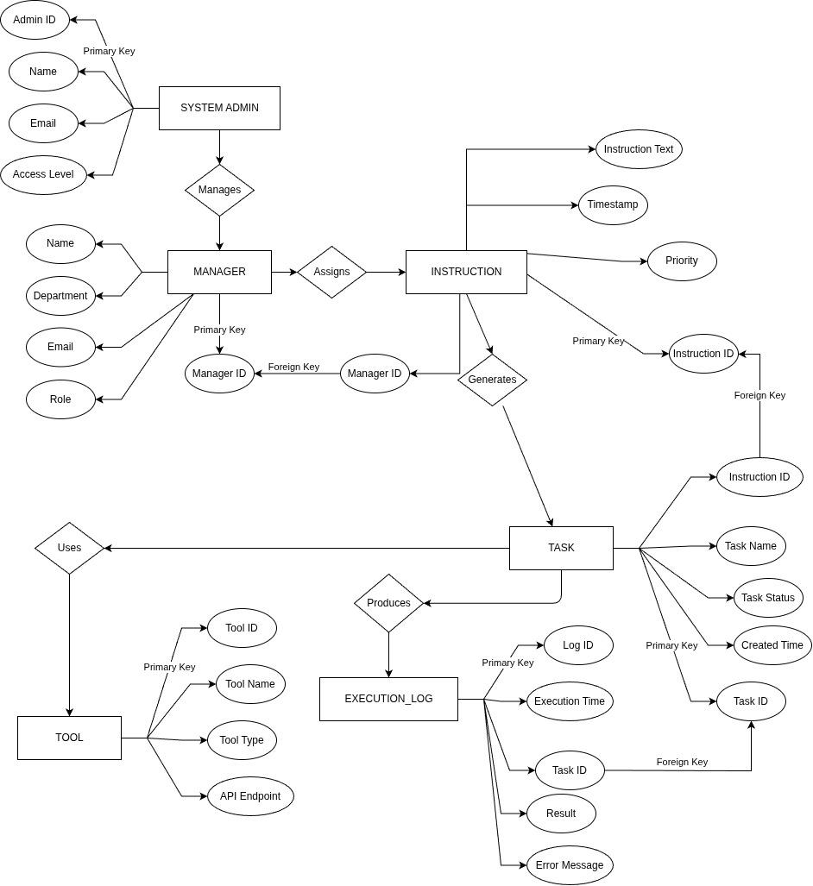Figure 3.5.1 - ER Model Diagram

3.6 Conclusion
The ER model of the AI-Based Digital Employee system clearly defines the structure of data and relationships between various components such as Manager, Instruction, Task, Tool, and Execution Log. It illustrates how instructions are transformed into tasks, executed using tools, and recorded in logs. This model provides a strong foundation for designing the database schema and ensures efficient data organization, consistency, and scalability of the system.
4. DATA FLOW DIAGRAM (DFD)
4.1 DFD Level 0 (Context Diagram)

4.1.1 Description
The Level 0 DFD represents the entire system as a single process and shows interaction with external entities.

4.1.2 Process
- AI-Based Digital Employee System

4.1.3 Input
- Instructions from Manager

4.1.4 Output
- Task Results
- Execution Reports

4.1.5 Flow
- Manager -> System -> Results/Reports

4.2. DFD Level 1

4.2.1 Description
The Level 1 DFD breaks the system into major processes.

4.2.2 Processes

4.2.2.1. Instruction Processing
- Receives instructions from Manager
- Validates and stores instruction

4.2.2.2. Task Generation
- Converts instruction into tasks
- Stores tasks

4.2.2.3. Task Execution
- Executes tasks using tools
- Tracks execution status

4.2.2.4. Logging & Reporting
- Stores execution logs
- Sends report to Manager

4.2.2.5 Data Flow Explanation
- Manager -> Instruction Processing -> Instruction DB
- Instruction Processing -> Task Generation -> Task DB
- Task Generation -> Task Execution
- Task Execution -> Tool
- Task Execution -> Logging System
- Logging -> Manager (Report Output)

4.3. DFD Level 2 (Detailed Breakdown)

4.3.1. Instruction Processing
- Input: Instruction
- Process:
  - Validate instruction
  - Store instruction
- Output: Valid instruction

4.3.2. Task Generation
- Input: Instruction
- Process:
  - Break into subtasks
  - Assign priorities
- Output: Task list

4.3.3. Task Execution
- Input: Tasks
- Process:
  - Select tools
  - Execute tasks
  - Monitor execution
- Output: Execution results

4.3.4. Logging System
- Input: Execution results
- Process:
  - Store logs
  - Generate report
- Output: Reports
4.4. Data Stores Description

4.4.1. Instruction Database
- Stores all instructions provided by managers.

4.4.2. Task Database
- Stores generated tasks and their status.

4.4.3. Execution Log Database
- Stores execution results, errors, and logs.

Table 4.5 - Data Flow Process table

Process | Input | Output | Description
Instruction Processing | Instruction | Valid Data | Validates input
Task Generation | Valid Data | Tasks | Creates tasks
Task Execution | Tasks | Results | Executes tasks
Logging | Results | Reports | Stores logs

4.6. Data Flow Diagram
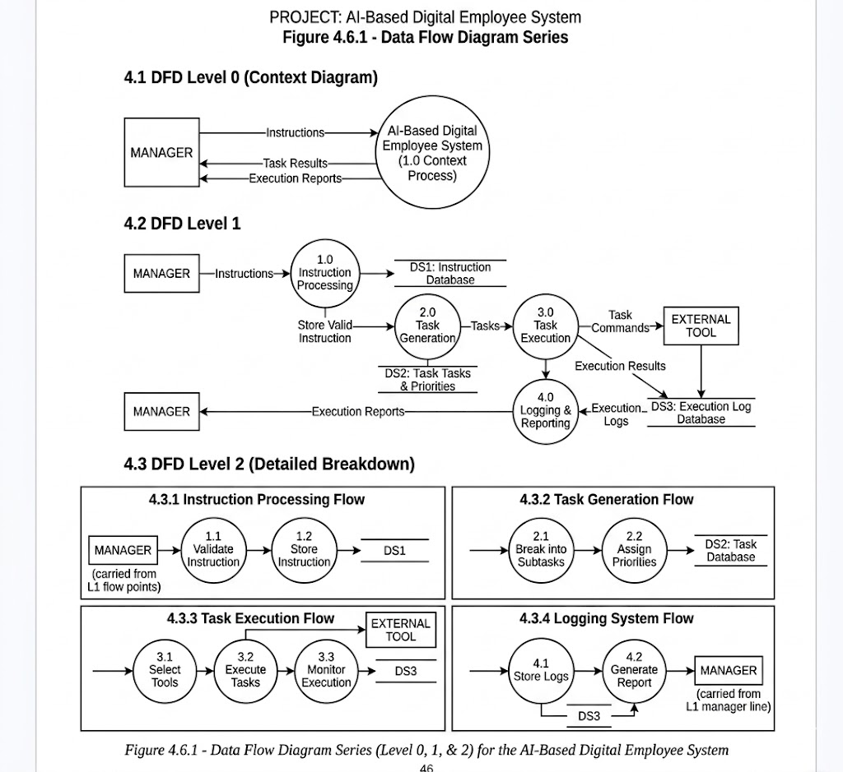
Figure 4.6.1 - Data Flow Diagram

4.7 STRUCTURE CHART
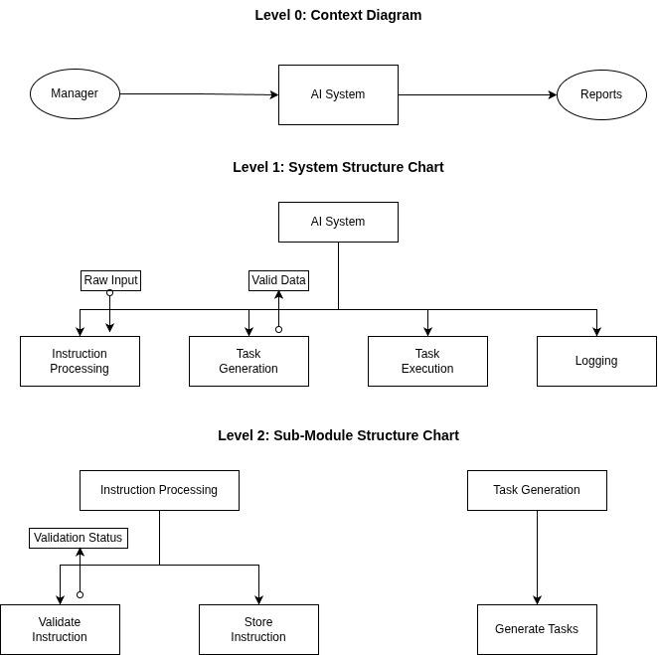
Figure 4.7.1 - Structure Chart Diagram

5. UML Diagrams

5.1 Use Case Diagram and User Flow
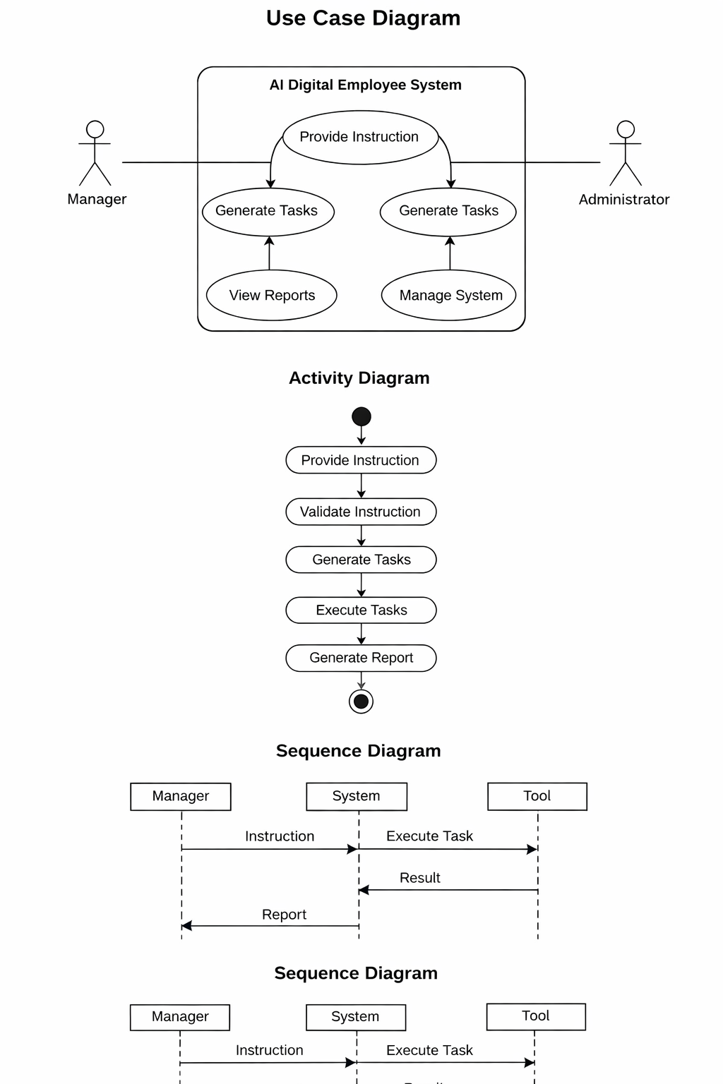Figure 5.1.1 - Use Case Diagram

Table 5.1.1 - Use Case Table
Actor | Use Case | Description
Manager | Provide Instruction | Sends tasks
Manager | View Report | Reviews output
Admin | Manage System | Controls system
System | Execute Tasks | Performs work

5.2 CLASS DIAGRAM

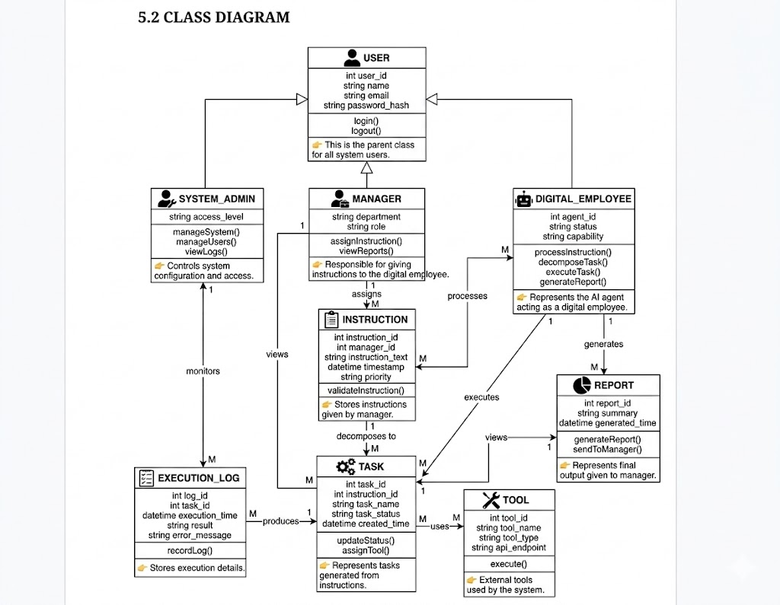
Figure 5.2.1 - Class Diagram

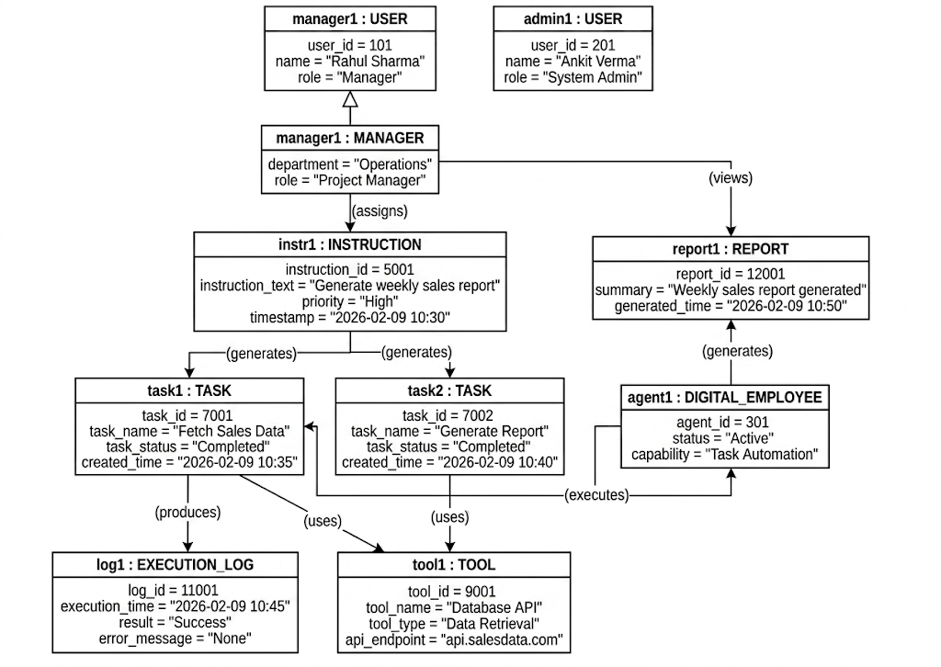
5.3 OBJECT DIAGRAM

Figure 5.3.1 - Object Diagram

5.4. Activity Diagram (User Flow)

Figure 5.4.1 - Activity Diagram

Table 5.4.1 - Activity Flow table
Step | Activity | Output
1 | Provide Instruction | Input
2 | Validate Instruction | Valid Data
3 | Generate Tasks | Task List
4 | Execute Tasks | Results
5 | Generate Report | Output

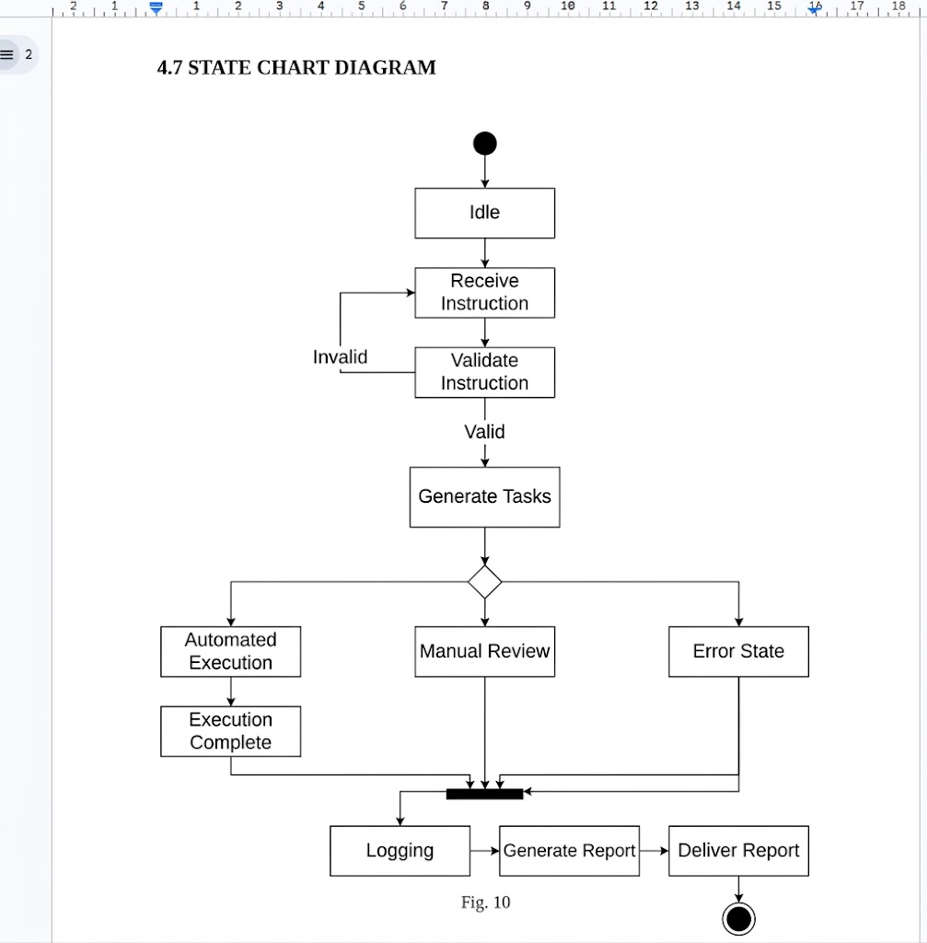
5.5 STATE CHART DIAGRAM
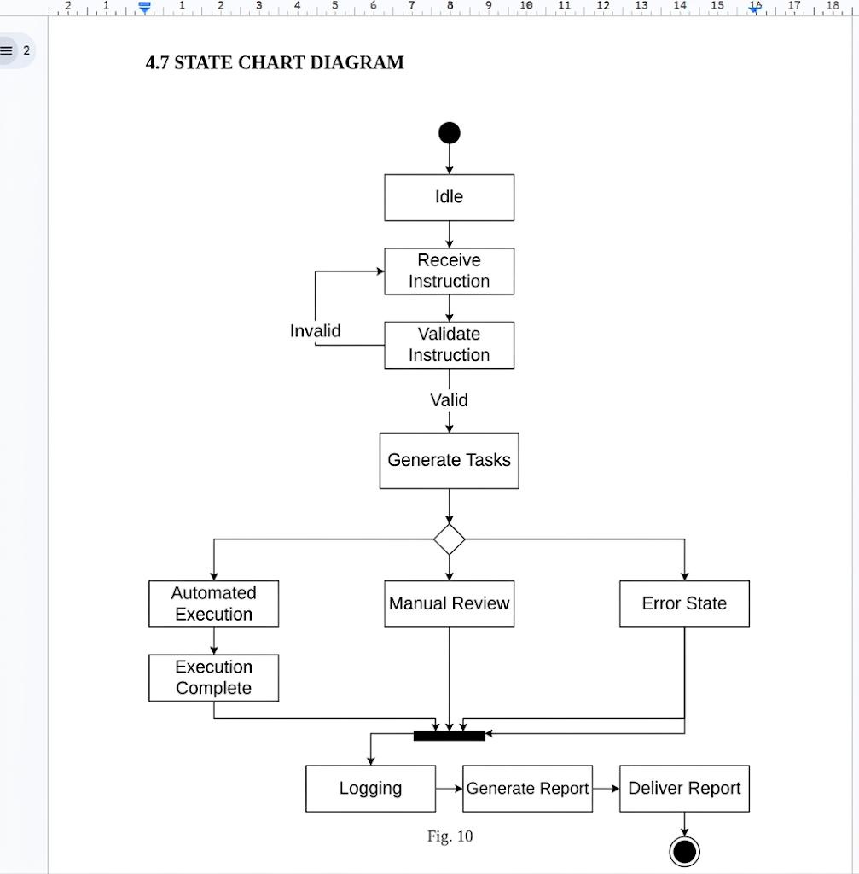
Figure 5.5.1 - State Chart Diagram
5.6. Sequence Diagram

Figure 5.6.1 - Sequence Diagram

Table 5.6.1 - Sequence Message table
Step | Sender | Receiver | Message
1 | Manager | System | Instruction
2 | System | Processor | Validate
3 | Processor | Task Module | Generate Tasks
4 | Task Module | Tool | Execute
5 | Tool | System | Result
6 | System | Manager | Report

5.7 COLLABORATION DIAGRAM

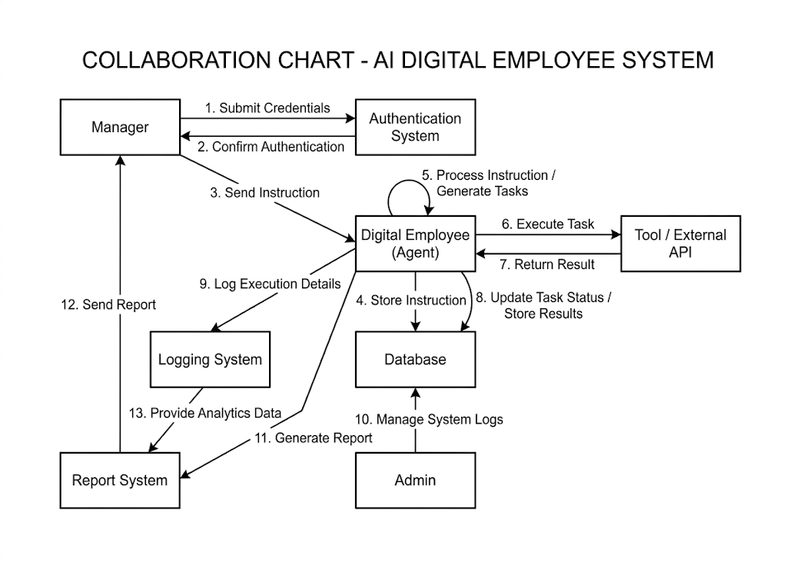
Figure 5.7.1 - Collaboration Diagram

6. Conclusion
The AI-Based Digital Employee Using an Agent system was successfully analyzed and modeled through various software engineering techniques. The project began with the identification of the problem and key stakeholders, followed by requirement analysis to define both functional and non-functional requirements of the system.
A structured Software Requirement Specification (SRS) was developed to clearly document system behavior and constraints. The Entity Relationship (ER) model provided a clear representation of data entities, attributes, and relationships, forming the foundation for database design. Data Flow Diagrams (DFDs) illustrated how data moves through different levels of the system, from instruction input to task execution and reporting.
Further, UML diagrams such as Use Case, Activity, and Sequence diagrams were used to represent user interactions, system workflows, and internal communication between components. These models collectively provide a comprehensive understanding of how the digital employee operates, processes instructions, executes tasks, and generates outputs efficiently.
Overall, the project demonstrates how an AI-driven agent can function as a digital employee by automating routine tasks while maintaining control, transparency, and scalability. The use of structured modeling techniques ensures that the system design is clear, organized, and ready for implementation in real-world scenarios.

Samuel Priyatam Dash
Regd No. - 2302040025

